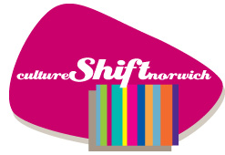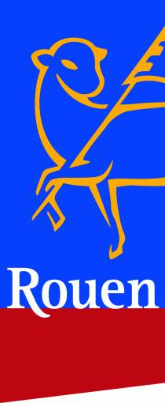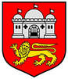
Cultural visit from Norwich’s twin city Rouen as they make a bid for European Capital of Culture 2028

On the weekend of 8/9/10 July, Norwich cultural leaders, councillors and council officers will be meeting two representatives from Norwich’s twin city of Rouen; Head of Culture Jean Gabriel Guyant and their European Capital of Culture bid lead Rebecca Armstrong who will be visiting the city alongside 35 members of the Norfolk & Norwich Rouen Friendship Association (NNRFA), who are hosting a visit by members of the Rouen/Norwich Club from Rouen at the same time.

Rouen is one of 11 French cities bidding to be European Capital of culture 2028. Already twinned with Norwich for over 60 years, the city has chosen Norwich to be a part of their bid strategy, along with 5 other European cities and is visiting cultural leaders in Norwich, King’s Lynn and Great Yarmouth to set the scene for the next ten years.

Whilst the twinning association members tour heritage spaces and sights of interest on Friday 8 July, the bid team representatives will visit Norwich Castle, Norwich Cathedral, the National Centre for Writing, the Norfolk and Norwich Festival, the Sainsbury Centre, Norwich Lanes and more. At City Hall, they will meet the Lord Mayor and Sheriff before presenting their ideas to a gathering of cultural leaders from across the city, setting the scene for making long-term cultural links and partnerships with the city to develop joint initiatives of artistic, heritage, economic and tourism. They are also especially interested in the geography of Norfolk and the connections through waterways.

“Working at a European scale enriches our project and means that we can project ourselves onto the horizon of 2028 while keeping in mind universal concerns,” explains Christine de Cintré, Vice-President of the association in charge of Rouen’s application. “By exchanging on a daily basis with towns that have similarities with Rouen and the Seine Normande Valley, we can validate our choices, and concretely improve our candidacy.”

Going forward, Norwich will benefit from being known as one of the cities of culture that Rouen Normande has chosen to work with, helping each other with joint marketing and tourism campaigns as well as exchange artistic initiatives. We are also both part of the UNESCO Creative Cities Network as Rouen is a UNESCO City of Gastronomy and the City of Rouen has asked for the support of the National Centre for Writing, lead of Norwich, UNESCO City of Literature.

French speaker Christine Wilson, a long-term member of NNRFA in Norwich said ‘It is fantastic to see the relationship with Rouen develop beyond the twinning association. For many years we have encouraged wider links in both cities and now it is finally blossoming. I am really happy.’

On Saturday 9 July, the bid team will head off to Great Yarmouth and then on Sunday 10 July, they will travel to King’s Lynn’s Groundwork Gallery and then around the north Norfolk coast before returning to France on Monday.

This will be the start of a new and richer working relationship between Norwich and Rouen, and a continuation of centuries of cultural connection and shared histories.

More information about Rouen plans here
https://www.ecocnews.com/news/item/371-rouen-2028-a-cultural-network-with-6-cities

For details, interviews and photos please contact Marion Catlin, Culture Shift Norwich, info@theshiftnorwich.org.uk or telephone 07946 261651

Background

Exactly twenty years ago, Norwich bid to be European Capital of Culture for 2008. Although the city didn’t win, losing out to Liverpool, the bid was the catalyst for a long-term cultural strategy for the city which saw us become a UNESCO City of Literature, a City of Refuge, increased investment in the Norfolk & Norwich Festival making it the 4th largest in the UK and a reputation for putting culture at the heart of community and development which brought funding and support to our cultural organisations.

Rouen is preparing its European Capital of Culture bid for 2028 and as part its plan, the bid team are making special relationships with 6 European cities: Hanover (Germany), Aveiro (Portugal), Kaunas (Lithuania), Skopje (Macedonia), Trondheim (Norway) and Norwich - with the intention of proving that in spite of Brexit, the UK is still culturally a part of Europe.

Normandy is a strong part of our heritage as Norwich Castle and Norwich Cathedral were built by the Normans from Caen stone, shipped by river and across the Channel. The Huguenots brought their weaving techniques to Norwich including the Jacquard loom, and we share many cultural roots. These are the foundations on which we can build a contemporary relationship with our Norman cousins.

Rouen Norwich Club visit
Thirty-five visitors from the Rouen-Norwich-Club in Norwich's twin city of Rouen are in Norwich from 7 to 11 July. The programme, arranged with the Norfolk & Norwich Rouen Friendship Association (NNRFA), includes a visit to the Great Hospital, a guided tour of Norwich, excursions to Great Yarmouth, Blickling Hall, and Cromer.

Most visitors will stay with members of the NNRFA. The trip normally takes place every two years, though postponed from 2020, with NNRFA members going to Rouen in alternate years. The last visit to Rouen was in 2019 when the two cities celebrated 60 years of twinning and the next is planned in 2023 during the Armada, the festival of tall ships. The aim of the twinning is to further links and exchanges between the two cities and many have taken place over the years. The connection has become stronger in the last few years as a renewed motivation to work together followed the UK’s exit from the European Union which has provoked new partnerships and joint projects.

In the group arriving next week are a number of representatives of cultural organisations in Rouen who will be meeting their counterparts from Norfolk Museums, The Garage, the National Centre for Writing and other cultural bodies in Norwich.

